FSC前端缓冲结构数据（IAD） – Page 1 of 3
(Chinese Version)

所有参赛队必须在截止日期前（截止日期见中国赛官方网站）完整填写并按照官方指定方式提交此表格。中国大学生方程式汽车大赛裁判委员会将审核车队提交的所有与规则不相符的请求，并给出是否予以采纳的决定。所有车队都会收到组委会发出的收函确认。前端缓冲结构数据报告(IAD)和相关计算说明务必以Adobe Acrobat(*.PDF)电子文档的形式提交。提交文件名称格式：车号_学校名称_赛事代码_IAD.pdf, 此处学校名称应该为中文全称。赛事代码FSCC,各车队按照此表格式填写提交，不得擅自改变格式。
*如学校被要求进行的任何材料整改，包括重新计算或者补充信息等，车队均应在一周（7天）内完成并重新提交，超过时限按照初次提交材料延期等同办法处理。

Note Bene: Pages 1-5 are the Chinese version of the IAD, and pages 6-9 are the English version. Overseas teams only need to complete pages 6-9.

学校名称: ____南京理工大学__________________
车 号: _____22_________________
车队联系人: _____陈康平____________手机： 15921879554 E-mail: 3086723496@qq.com
指导教师: ____周云波_______________手机： 15996232137 E-mail: 15996232137@163.com

缓冲结构所用材料 | 蜂窝
结构形状描述 | 矩形凸台
缓冲块与防侵入板连接方式 | 粘合
防侵入板与车架前隔板连接方式 | 焊接
峰值减速度 (应<= 40 g's)
均值减速度 (应<= 20 g's)
YES
确认缓冲块拥有的最小体积为宽200mm*高100mm*长200mm

力—位移 曲线.

图 1: 碰撞中的力—位移曲线
补充材料：

审阅决议
_______________________________________________________________________________________

审阅人：__________________________________________ 日期：_____________

注意：反馈后的此审阅决议表必须打印后在比赛现场技术检查时提交。

FSC 前端缓冲结构数据（IAD） – Page 2 of 3

学校名称: ______南京理工大学__________________ 车号 : _______22___________

能量—位移曲线. 加速度-时间曲线

(仅非标准防撞块需要填写) (仅非标准防撞块需要填写)

图 2: 能量—位移曲线 图3：加速度-时间曲线
(动态碰撞必须包括位移坐标从接触开始到速度为0) (仅非标准防撞块需要填写)
(仅非标准防撞块需要填写)

照片应包含缓冲块、防侵入板（可清晰显示防侵入板距离刚性结构距离不小于50毫米）  (仅非标准防撞块需要填写) |  | 照片应包含缓冲块、防侵入板（可清晰显示防侵入板形变小于25.4毫米）  (仅非标准防撞块需要填写)
图 4: 实际缓冲结构照片 图 5: 碰撞后缓冲结构照片

吸收能量 (J):  必须 >= 7350 J  (仅非标准防撞块需要填写) |  | 车架前隔板前是否存在前定风翼结构? | 是/否
缓冲块压缩变形行程 (mm):  (仅非标准防撞块需要填写) |  | 定风翼是否参与本碰撞? | 是/否
缓冲块碰撞后回弹量 (mm):  (仅非标准防撞块需要填写) |  | 测试方法:(如：碰撞、 下落等)  (仅非标准防撞块需要填写)
防侵入板变形 (mm)  (仅非标准防撞块需要填写) |  | 测试地点:(动态测试需为专用测试设备)  (仅非标准防撞块需要填写)

FSC前端缓冲结构数据（IAD） – Page 3 of 3

学校名称: ______南京理工大学__________________ 车号 : _____22_____________

缓冲块标准三视图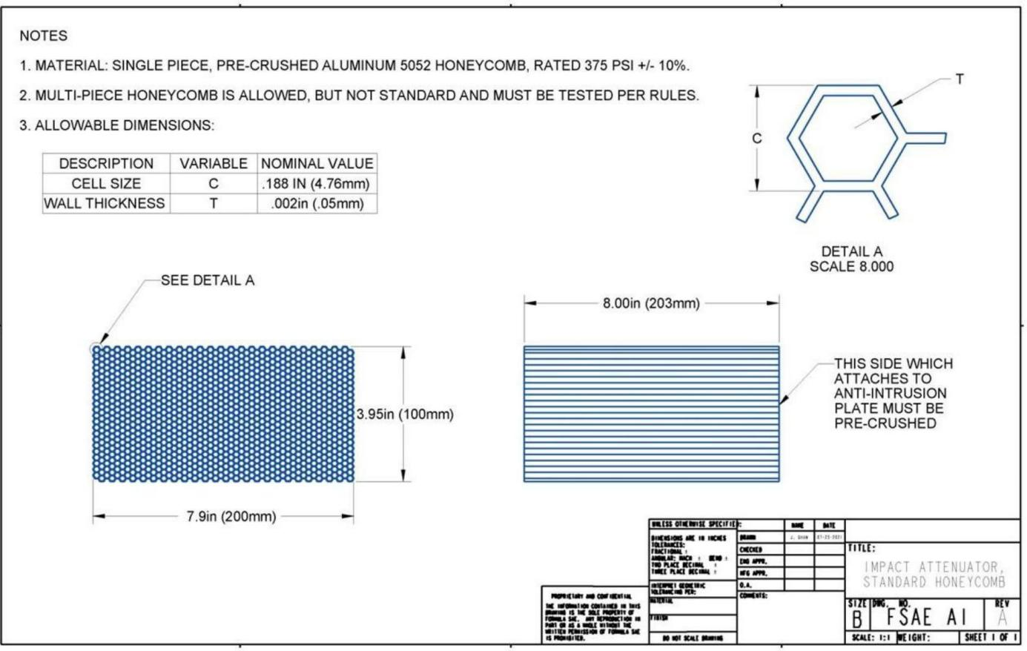
图 6:缓冲块工程图纸或照片

长 (车辆前向): __202______毫米(>=200mm)
宽(车辆横向): __203______毫米 (>=200mm)
高 (车辆垂向): ___110_____毫米(>=100mm)
缓冲块宽和高均大于200毫米: 是/否

补充信息及附加材料（不得加页超过5页）：
测试设备图，测试照片，试验报告（包括方法选择的理由及其优缺点分析），补充材料等

1 、标准防撞块的设计及其在防侵平板上的位置(如图)

标准：

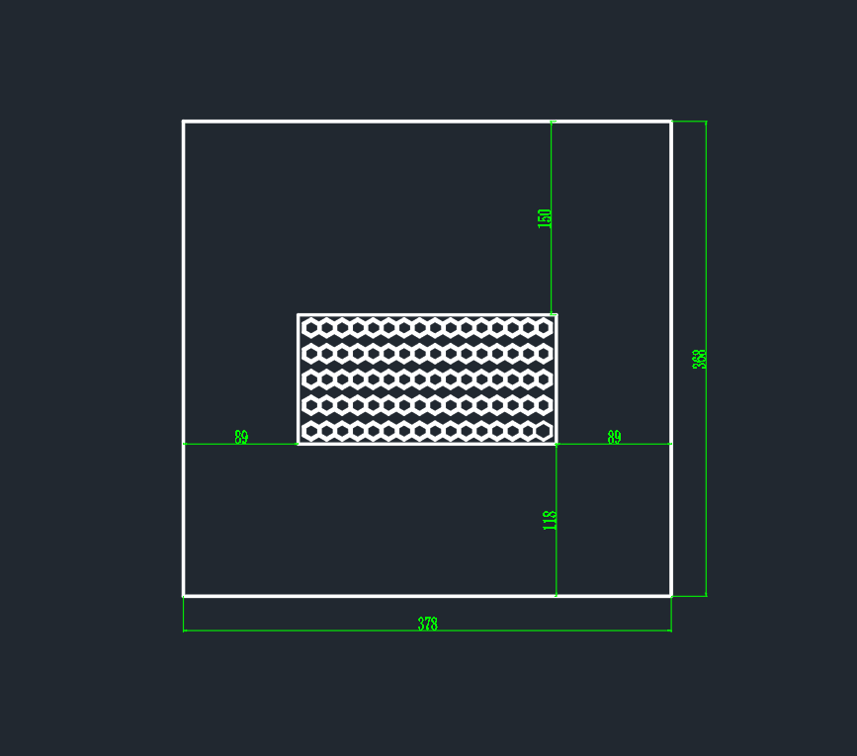
2 、 防撞块、防侵板与前隔板连接图片（采用 CATIA 按标准缓冲块尺寸建模,安装孔可微调）
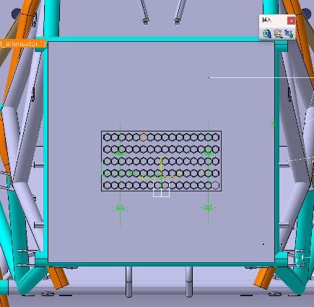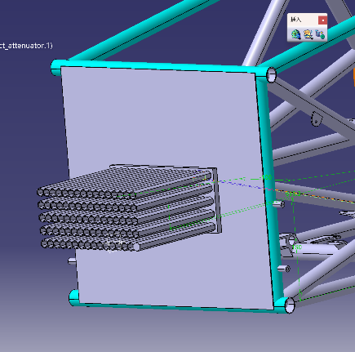
注：防侵入板为 1.5mm 的钢板，用焊接与前隔板连接。
3、防撞块实图

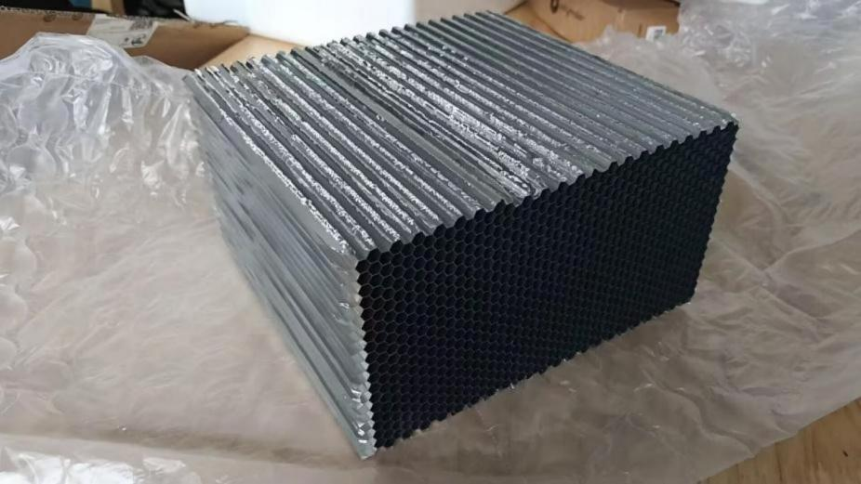



4、前翼连接处强度计算。
计算证明：
4 颗8.8级M4的螺栓破坏载荷的表达式为： Fs =σ1× S = 4 × 0.6× 800× 2 × 2×πN = 24. 12KN
标准缓冲结构的峰值载荷 ：F = 60KN
结构测试中的峰值力和前翼破坏载荷的合力为：
F=Fs+Ft = 24.12KN + 60KN = 84.12KN < 120KN
因此，缓冲结构和前翼的组合体符合规则 T3.21.2 中的峰值减速度的要求。
5、防撞块凭证

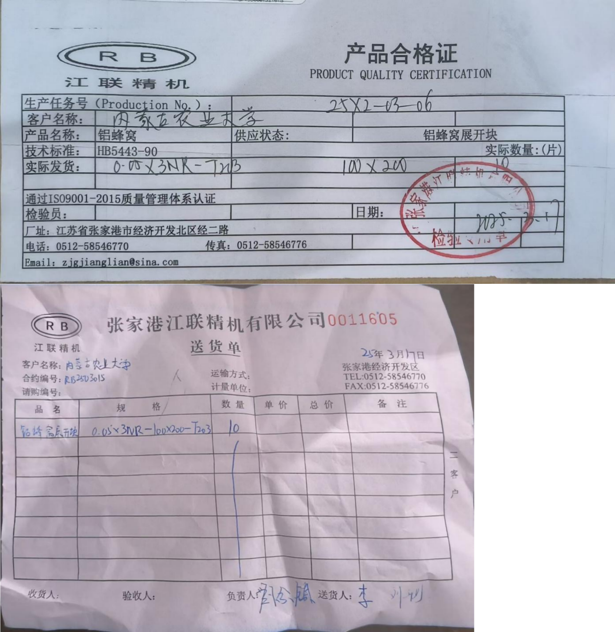


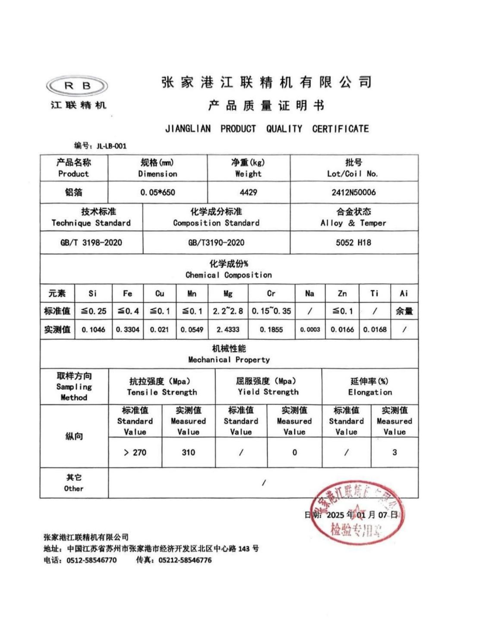
6、防撞块粘接强度计算证明

DP460 的特性及参数：
特性：A、长操作时间的坚韧型环氧树脂 B、2~4 小时达到操作强度 C、满足MIL-A-23941A 标准
混合比（容积）B：A：2：1
粘度近似值 75 °F （24 °C）（CPS）：4500
75 °F （24 °C）时的操作时间近似值：60 分钟
75 °F （24 °C）时 的T 型剥离（PIW）：60；（1Piw=17. 858kg/m）
重叠剪切强度（PSI）：（145PSI=1Mpa）



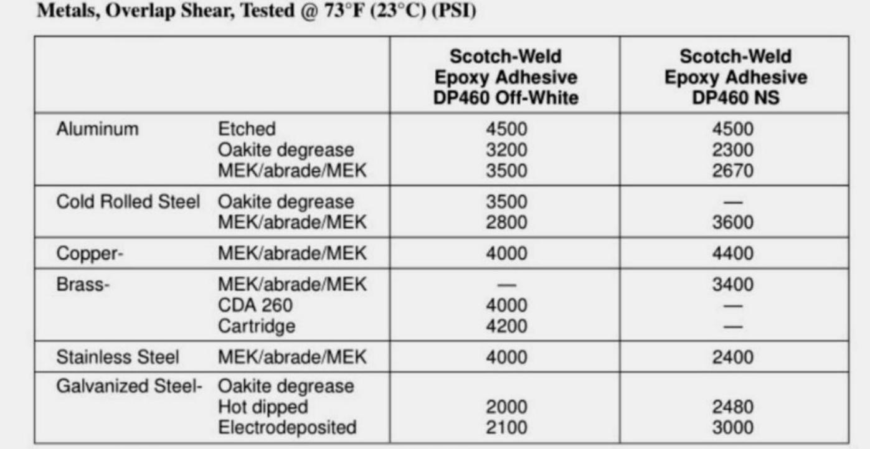

操作流程：
1、首先要清洁材料表面，再施胶，可以用异丙醇去除油脂等脏物。
2、建议使用EPX 塑料胶枪及混合长管配套使用。
3、操作时间：60 分钟，完全固化需要 24 小时。
注意：施胶没有按照规定的比例混合，或者混合不均匀，会导致粘接强度达不到，或者无法固 化等。

计算证明：
8 颗 8.8 级M8 的螺栓能承受的剪切力表达式为：
F1 = 8×σ1×π × r × r = 8× 0.6× 800×π × 4 × 4N = 192921.6N
粘接面积表达式为： S= a × b = 203 × 110 = 22330mm^2
粘接所能承受的剪切力表达式为：
F2 =σ 2 × S = 4500 ÷ 145Mpa × 22330mm^2 = 693000N >F 1 = 192921.6N
DP460 胶粘剂的粘结强度大于螺栓连接的强度，因此，DP460 胶粘剂粘接缓冲结构和防侵平板的 方法符合规则。

Impact Attenuator Data Report (IAD) – Page 1 of 3

All participating teams must complete the entire form and submit it in the manner specified by the official website of the Formula Student China Competition before the deadline (deadline stated on the official website). The Referee Committee of the Formula Student Competition China will review all requests submitted by teams that do not comply with the rules and decide on whether to accept them. All teams will receive a confirmation letter issued by the organizing committee. The Impact Attenuator Data Report (IAD) and relevant calculations must be submitted in the form of an Adobe Acrobat (*.PDF) soft copy. The filename format for the submission should be: CarNumber_UniversityName_EventCode_IAD.pdf, where the university name should be in full Chinese name. The event code is FSCC. All teams must fill out and submit the form in this format and are not allowed to change the format without authorization.
If the university is requested to make any modification, including recalculations or providing additional information, the team must complete and resubmit them in a week (7 days). Failure to meet the deadline will result in the same punishment as a delayed initial submission.

University Name: __________________________
Car Number: ______________________________
Team Contact Person: ___________ Contact Number： ___E-mail: _____________________
Team Advisor: ___________Team Advisor Mobile Number： E-mail: _________________

IA material(s) used
Description of form/shape
IA to Anti-Intrusion Plate
attaching method
Anti-Intrusion Plate to
Front Bulkhead attaching
method
Peak deceleration (<= 40g)
Average deceleration (<=20 g)

Confirm that the attenuator has a minimum volume of
200mm Wide x 100mm High x 200mm Long
YES/NO
Force-Displacement Curve

Figure 1: Force-Displacement Curve during collision
Additional Information:

Review Decision
_______________________________________________________________________________________
Review person：__________________________________________ Date：_____________
Note: After the review, this review decision form must be printed and submitted during the technical inspection at the competition venue.
2024 FSC Impact Attenuator Data Report（IAD） – Page 2 of 3

University Name: ________________________ Car Number : __________________

Energy - Displacement Curve Acceleration - Time Curve
Only non-standard impact attenuators need to be filled out. Only non-standard impact attenuators need to be filled out.

Figure 2: Energy Displacement Curve (dynamic tests Figure 3: Acceleration Time Curve (dynamic
must show displacement during a collision and after v=0) tests must show displacement during a collision
and after v=0)
Only non-standard impact attenuators need to be filled out.

Picture of IA, Anti-Intrusion Plate  which also shows the method of  spacing it at least 50mm from any rigid structure  Only non-standard impact attenuators need to be filled out. |  | Picture of IA, Anti-Intrusion Plate  which shows the deflection was less than 25.4mm  Only non-standard impact attenuators need to be filled out.
Figure 4: Picture of Attenuator as Constructed Figure 5: Picture of Attenuator after Impact

Energy Absorbed (J):  Must be >= 7350 J |  | Vehicle includes front wing in front of front bulkhead? | Yes/No
IA Max. Crushed  Displacement (mm): |  | Wing structure included in the test? | Yes/No
IA Post Crush Displacement -  demonstrating any return (mm): |  | Test Type: (e.g. barrier test, drop test, quasi-static crush)
Anti-Intrusion Plate Deformation (mm) |  | Test Site:(dynamic testing must be conducted using dedicated testing equipment)
FSCC Impact Attenuator Data Report（IAD） – Page 3 of 3

University Name: ________________________ Car Number : __________________

Three views of the Impact Attenuator
Figure 6: Engineering Drawing/Picture of the Impact Attenuator

Length (Vehicle Forward): __________ millimeters (>=200mm)
Width (Vehicle Sideways): __________ millimeters (>=200mm)
Height (Vehicle Vertical): ___________ millimeters (>=100mm)
Impact Attenuator width and height both greater than 200 millimeters: Yes/No

Additional Information and Material (no more than 5pages):
Picture of the testing setup and equipment, testing report (including the reason for choosing this testing method and its pros and cons), and other additional materials etc.

